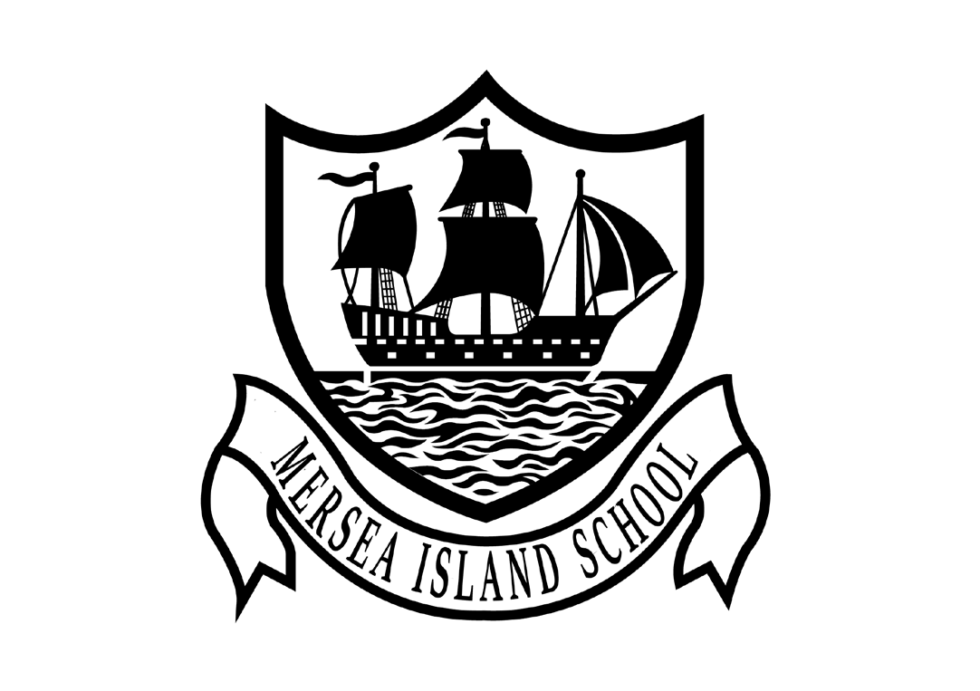

History Policy
2024
Mersea Island School

Barfield Road, West Mersea, Colchester, Essex, C05 8QX Tel: 01206 382736
Email: office@merseaschool.org
Website: www.merseaschool.org



Mersea Island School
Policy for History

Sharing our vision
Mersea Island School is proud to be at the heart of our island community. We recognise the importance of strong partnerships and work together, closely, with all members of our community to provide our pupils with a wide range of learning opportunities, both within and beyond the school setting. Our school culture is founded on the belief that every child has the capacity to be successful. We believe learning should be enjoyable and memorable and embrace the creative aspects of the curriculum.

Our curriculum drivers are based on:

C ommunity
A spiration
R espect
E njoyment

At our school we care about each and every child and their family. We pride ourselves on the strength of our relationships and we encourage open and honest conversation which is based on mutual respect and a shared view that every child leaves us having achieved the very best they possibly can. We equip our pupils with the necessary life skills to be successful, kind and respectful members of the wider world.

Rationale for History
At Mersea Island School we are building a community, at the heart of island life, which is founded on mutual respect, tolerance, resilience and honesty. All members of the school are expected to take responsibility to ensure everyone feels safe and valued. As a community we work to equip everyone for the demands and opportunities of education, work and life. We teach through an engaging, constantly evolving and creative curriculum to ensure learning is purposeful and enjoyable. Through effective marking, feedback and assessment we strive to promote independent, reflective learners who are fully involved in their learning. Teachers have high expectations and pupils take an active role in moving their learning forward by having a clear understanding of what they need to do next to achieve their targets.
The history curriculum is carefully sequenced to build knowledge, skills, vocabulary and experiences which build on prior learning and enable pupils to make connections between ideas, their learning and the wider world. We want pupils to have an appreciation of how important a knowledge of history is in our lives and our aim is to nurture a sense of fun and curiosity about the subject. We want the children to see history as being relevant to their world and applicable to everyday life as well as being something that they will need as they move on through their school life and ultimately into the world of employment and beyond. To that end, a high-quality, interrelated and creative history experience should be one that develops the children’s knowledge and understanding of the world, their ability to question it and apply the skills they have learnt in a variety of ways.

Intent
The aim of history teaching at Mersea Island School is to provide a high quality history education that inspires in pupils a curiosity and fascination about the history of the world and understanding about the life of people who lived in the past that will remain with them throughout their lives.
Our intent therefore is:
- To deliver the statutory requirements of the National Curriculum across the Foundation Stage, Key Stage One and Key Stage Two.
- To develop historical knowledge, skills and deep understanding, building on previous learning.
- To encourage pupils to reason about historical concepts and facts.
- For pupils to be able to make connections between their learning and how it is useful in everyday life.
- To promote confidence, competence and fluency with their writing through historical study.
- To promote enjoyment and enthusiasm for learning through practical activity, exploration and discussion.
- To develop resilience and perseverance in problem solving.
- To nurture a questioning and inquisitive mind.
- To plan and provide regular opportunities for pupils to use and apply their knowledge and skills in a range of contexts – in line with the mastery approach.
- To encourage pupils to explain their thinking.
- To promote high standards of history through setting high expectations.
- To teach children a sense of chronology and through this, develop a sense of identity, and a cultural understanding based on their historical heritage. Thus, they learn to value their own and other people's cultures in modern multi-cultural Britain and, by considering how people lived in the past, they are better able to make their own life choices today. In our school, history makes a significant contribution to citizenship education by teaching about how Britain developed as a democratic society. We teach children to understand how events in the past have influenced our lives today; we also teach them to investigate these past events and, by doing so, to develop the skills of enquiry, analysis, interpretation and problem-solving.

Objectives
- to foster in children an interest in the past, and to develop an understanding that enables them to enjoy all that history has to offer;
- to enable children to know about significant events in British history, and to appreciate how things have changed over time;
- to develop a sense of chronology;
- to know and understand how the British system of democratic government has developed and, in so doing, to contribute to a child's citizenship education;
- to understand how Britain is part of a wider European culture, and to study some aspects of European history;
- to have some knowledge and understanding of historical development in the wider world;
- to help children understand society and their place within it, so that they develop a sense of their cultural heritage;
- to develop in children the skills of enquiry, investigation, analysis, evaluation and presentation.

Implementation
The majority of the National Curriculum content of history is taught through half termly themes where learning, knowledge and skills can be focussed, developed and the children can achieve depth in their learning. During other themes, cross curricular links are utilised effectively so that children can embed skills and understanding and see the wider application and relevance of their previous learning.
Impact
Outcome and progress evidence a broad and balanced history curriculum, demonstrating children’s acquisition of key knowledge. Children will know more, remember more and understand more about History. They will understand and use the key skills of chronological understanding, knowledge and understanding of events in the past, historical interpretation, historical enquiry and organisation and communication. As historians, children will learn lessons from history to influence the decisions they make in their future lives.

What should you expect to see in the learning environment?
Nursery
History is covered through Understanding of the World within the Early Learning Goals (ELGs). The focus is on beginning to make sense of their own life-story and family’s history. Children investigate this through discussions, circle time and role play.

Reception
We teach history in reception classes as an integral part of the topic work covered during the year within Understanding of the World (ELG). History makes a significant contribution to developing a child's understanding of the world, through exploring the concept of the past through their own history, and discovering the meaning of vocabulary ('new' and 'old', for example) in relation to their own lives. Children will talk about the lives of people around them and their roles in society. They will know and be able to talk about some similarities and differences between situations and characters in the past and now. Children will be provided with opportunities to discuss this during circle time and through effective questioning within the learning environment. Vocabulary will be modelled to support these discussions and high quality resources are used for the children to support their learning. Children will build practical timelines and will further enhance their knowledge through role play and sharing books during story time.
In Years 1-6
- A narrow focus; with depth, variation, precise questioning and dialogue with pupils to assess conceptual and procedural knowledge.
- The vast majority of pupils progressing through the curriculum content at the same pace
- A range of direct whole class teaching, mixed attainment partner work and an emphasis on independent exploration and guided practice
- Teachers and Learning Support Assistants being facilitators of the learning, providing oral feedback to support and extend pupils' thinking and deepen their level of understanding.
- Staff using scaffolding and questioning to support and challenge all pupils.
- Targeted teaching is carried out to support those pupils that need further input and support.
- More able children being challenged through skillful questioning, the use of complex problem solving or investigative tasks and an expectation that he/she will be able to successfully apply his/her knowledge and skills in a wide range of contexts.
- Pupils are encouraged to be resilient and to have an ‘I can’ approach towards developing their historical understanding.
What should you expect to see in the books?
EYFS
Nursery and Reception collect evidence throughout the year so that they are able to show the children’s attainment linked to Development Matters and the Early Years Foundation Stage Goals. Tapestry is used to document observations of children, at home and in school. Feedback is given and understanding is secured/extended through discussion and effective questioning. This can then be revisited in later activities. Where possible marking is done with the children and follows our marking policy.

In Years 1-6
- High presentation expectations are reinforced through all written work.
- Evidence of pupils developing fluency of a skill with a degree of accuracy, including evidence of reasoning with some explanations of how they reached their answers, linked to the vocabulary in the year group.
- Clear evidence of progression and differentiation- evidence of children achieving greater depth.
- Where children have received additional adult support or ‘targeted teaching’ this will also be clearly indicated.
- Children’s work will be marked in lessons where possible with adult support to correct misconceptions and next steps given to deepen and extend learning.
- Pupils will use their books to record when and where it is appropriate to the learning.

The Curriculum

EYFS
Teachers and practitioners support children in developing their understanding of history in a broad range of contexts in which they can explore, enjoy, learn, practise and talk about their developing understanding. Children use their knowledge and skills in these areas to solve problems, generate new questions and make connections across other areas of learning and development.
Children in the EYFS learn by playing and exploring, being active, and through creative and critical thinking which takes place both indoors and outside. We recognise that children learn through routine, continuous provision and incidental learning opportunities, as well as planned sessions and activities. Historical understanding can be developed through stories, songs, games, routine, questioning, imaginative play, child-initiated learning and structured teaching. The learning will focus on the expectations from Development Matters / Early Years Outcomes.

In Years 1-6
History teaching focuses on enabling children to think as historians. We place an emphasis on examining and handling historical artefacts and primary sources. In each key stage, we give children the opportunity to visit sites of historical significance. We encourage visitors to come into the school and talk about their experiences of events in the past. We recognise and value the importance of stories in history teaching, and we regard this as an important way of stimulating interest in the past. We undertake fieldwork by interviewing family and older friends about changes in their own and other people’s lives. We use drama, dance and poetry to act out historical events. We focus on helping children to understand that historical events can be interpreted in different ways, and that they should always ask searching questions, such as 'how do we know?', about information they are given. We recognise that in all classes, children have a wide range of ability in history, and we seek to provide suitable learning opportunities for all children by matching the challenge of the task to the ability of the child. We achieve this by: setting tasks which are open-ended and can have a variety of responses; setting tasks of increasing difficulty, some children not completing all tasks; grouping children by ability in the room, and setting different tasks for each ability group; providing resources of different complexity, depending on the ability of the child; using classroom assistants to support children individually or in groups.

Planning
Teachers tailor their planning to suit the learning needs of the pupils within their group. Plans give a clear outline of the objectives for each lesson and show the differentiated objectives and activities. Where it is appropriate, teachers use their expertise to extend and broaden pupils’ learning experiences beyond the classroom setting. Teachers are continuously involved in evaluating and reflecting on the teaching sessions and planning is adapted accordingly on a daily basis. Class teachers keep records to track pupil knowledge, skills and understanding. This enables timely interventions to be incorporated into future planning and teaching assistant time to be directed effectively.

The Contribution of History to Other Subjects
English
History contributes significantly to the teaching of English in our school by actively promoting the skills of reading, writing, speaking and listening. Some of the texts that we use are historical in nature. Children develop oracy through discussing historical questions or presenting their findings to the rest of the class. They develop their writing ability by composing reports and letters and through using writing frames. Children deploy their SPAG knowledge in their history writing and indeed they are challenged to stretch themselves in this respect. By Year 6 they are developing the skills of writing balanced arguments for history questions.
Mathematics
History teaching contributes to the teaching of mathematics in a variety of ways. Children learn to use numbers when developing a sense of chronology through doing activities such as time-lines. Children learn to interpret information presented in graphical or diagrammatic form.
Information and Communication Technology (ICT)
We use ICT in history teaching where appropriate and where it is practical to do so. Teachers regularly use ICT to present information to a class and use sites such as Google Earth and airpano.com to engage pupils in seeing a range of locations. Children use ICT in history to enhance their skills in data handling, in presenting written work and researching information. Children have the opportunity to use the digital camera.
Personal, Social and Health Education (PSHE) and Citizenship
History contributes significantly to the teaching of personal, social, citizenship and health education. Children develop self-confidence by having opportunities to explain their views on a number of social questions such as how society should respond to various situations. They discover how to be active citizens in a democratic society by learning how laws are made and changed. They learn how to recognise and challenge stereotypes and to appreciate that racism is a harmful aspect of society. They learn how society is made up of people from different cultures and start to develop tolerance and respect for others.
Spiritual, Moral, Social and Cultural Development
When teaching history we contribute to the children’s spiritual development where possible. We also provide children with the opportunity to discuss moral questions, or what is right and wrong, when studying topics such as child labour in Victorian Britain. Children learn about the development of Christianity from Roman times and changes in the church in Tudor times. They find out how British society has changed over time. The history programme of study enables children to understand that Britain’s rich cultural heritage can be further enriched by the multi-cultural British society of today. They learn that different religions and cultures use different calendars. They explore different cultures with different approaches to religion e.g. Native Americans, The Maya and Ancient Egyptians.
Fundamental British values
History lessons are an arena for promoting knowledge and understanding of the main British Values (rule of law, individual liberty, mutual respect and tolerance of different faiths and beliefs) and these overlap with citizenship as outlined above and these are integrated into the Curriculum according to the Prevent Strategy. History is enhanced by talking to older generations, especially in KS1. This helps to promote mutual understanding and respect. Some examples of visitors that come into school are those in Year 1 when learning about the 1960s or childhood/homes in the past.

The teaching of history to children with SEND
It is part of the school curriculum policy to provide a broad and balanced education to all children. We provide learning opportunities which are matched to the needs of all children Work in history should consider the targets set for individual children in their Education Healthcare Plans (EHCPs) and in their progress reviews. A wide range of resources are used to engage, inspire, support, extend and enhance the learning experiences of pupils, with an emphasis on using concrete resources to support foundational enquiry. For those pupils who are working well above National expectations, learning objectives and materials are chosen to broaden and extend their learning, focusing on deepening their understanding through conceptual variation. Throughout the year, there are several opportunities for these pupils to work amongst others of a similar ability outside of the classroom setting.

Recording and Presentation
High standards of presentation are expected from all pupils. There is a very strong focus on this so that the pupils develop a good understanding of the importance of working with accuracy. Pupils are encouraged to make careful jottings and show their working methods fully. Pupils’ books will not evidence all work completed as there is a much greater emphasis on the importance of practical sessions.

Marking and Feedback
Work is marked for accuracy in order to check understanding. It is also undertaken in order to identify the ‘next steps’ in a pupil’s learning. Pupils are expected to self-assess their work using their 1,2,3 checks and respond to teacher comments; this may involve talking with the teacher, writing a comment, the completion of corrections or an extension task. We believe it is essential to have good dialogue between the pupil and teacher to promote high levels of engagement. Pupils know what they need to do and where to go should they need further help. Parents are encouraged to share in the learning journey, in addition to the termly reports, curriculum information events and the information they receive at parent’s evenings can support this.

Assessment
At Mersea Island School we recognise that effective Assessment for Learning (AfL) lies at the heart of a mastery curriculum. The assessment procedures within our school encompass:
Short term assessments – These are usually on-going and involve responding effectively to the needs of pupils within daily teaching sessions. A great deal of short term assessments are observed and immediate verbal feedback is given to the children. These assessments are closely matched to the teaching objectives and ‘shape’ our daily planning so that it is tailored to the learning needs of the pupils. In Reception and KS1 assessments are gathered through observations of children during both adult initiated and child-initiated learning and are cross referenced to the age related expectations.
Medium and long term assessments – teachers use their ongoing observations, discussions, marking and notes against objectives at the end of each theme and then the year to ascertain gaps in learning for individual children and where they have exceeded expectations. These are collated and used in conjunction with the National Curriculum statements to enable teachers to make a judgement about where that child is in relation to age related expectations.

Reporting
At Mersea Island School we very much value working in partnership with parents/carers.
We aim to keep parents/carers up to date with their child’s/children’s progress and learning needs. We issue reports and offer parent consultations during the autumn and spring terms and provide a full annual report at the end of the summer term. We also seek opportunities to discuss any important aspect of a pupil’s progress throughout the year by arranging additional meetings with parents/carers. We have an ‘open door’ policy and actively encourage parents to come and talk to staff should they have any queries or concerns. In addition, we offer curriculum information evenings for parents at various times throughout the year.

Monitoring
Monitoring of the standards of pupils’ work and attainment in history is ongoing throughout the year. The subject leader, in addition to senior leadership staff, engage in regular learning walks, monitoring conversations and some lesson observations, planning is shared and there is ongoing dialogue between staff. Opportunities for discussion with pupils, parents, staff and governors are planned throughout the year to allow the subject leader to gain a real insight into the learning needs of all, with a view to raising standards further. Opportunities are given during the staff INSET calendar for subject leaders to hold a ‘subject clinic’ where all staff can ask questions and the subject lead can deliver updates, gather information and offer support for their subject.

Equality
We aim to provide all our pupils with the opportunity to succeed, and to reach the highest level of personal achievement. To achieve this we will ensure:
- Curriculum planning reflects a commitment to equality;
- The curriculum prepares pupils for life in a diverse society and uses opportunities to reflect the background and experience of pupils and families in the school;
- There will be opportunities in the curriculum to explore concepts and issues related to identity and equality;
- The promotion of attitudes and values that challenge discriminatory behaviour and language;
- The use of non-stereotyped materials which reflect accurately a range of cultures, identities and lifestyles.
This policy should be read in conjunction with the following policies:
RSE, Assessment, Marking and Feedback Policy, Equalities Policy, SEND Policy, Disadvantaged Policy, Looked After Children Policy
This policy was reviewed and revised on: 1st February 2024
By: Miss Prior (Subject Lead)
Renewal date: January 2025

